
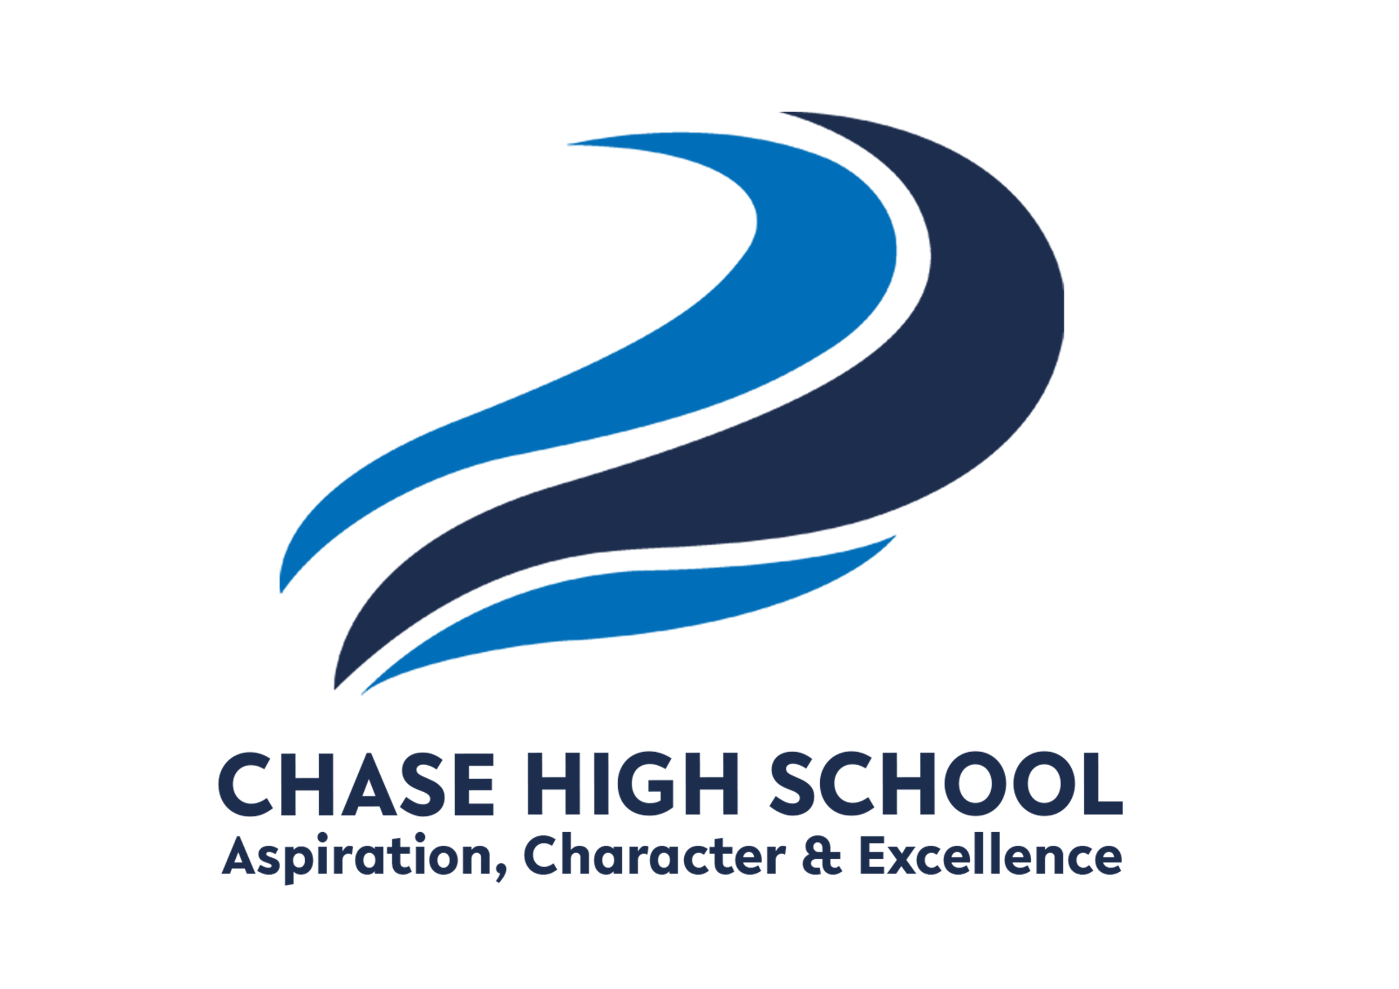
Curriculum Intent: The Media Studies department at Chase High School aims to develop student’s ability to engage with a variety of different media texts. Students will understand the importance of the media industry, the impact it has on the world and how the target audience carefully constructs media text for consumption. They will creatively design, edit and produce their own media products for their coursework, gaining knowledge in Photoshop to produce creative new media products.
Subject: Media Studies
Year Group: 10

TERM 1 | TERM 2 | TERM 3
KNOWLEDGE/SKILLS  Introduction to media / Knowledge  Component 1: Exploring Media Products  Students will explore the concepts needed to successfully complete assessed coursework. Practical skills are also developed.  Practical skills: Mood boards / mind maps / Photoshop techniques / storyboarding / typography  Component One Knowledge:  Creating a questionnaire  Purpose of Media products  Target Audiences  Social Class / psychographics  Textual Analysis if media products  Magazine / film poster layout keywords  Genre  Camera shots & angles  Propp & Todorov  Mise en scene  Sound | KNOWLEDGE/SKILLS  Component 1: Exploring Media Products  January – May  Pupils complete an assessed piece of work on a theme provided by the exam board. (This changes every year).  Vocational Context given to student – they will explore a certain theme.  Use research techniques to select media products.  Task1 – Investigate Media Products  One from these sectors:  Audio / moving image, print and interactive media products.  Look at forms / purposes / types of audiences.  Task 2 - Explore how media products are created to provide meaning and engage audiences  how genre, narrative and representation are used  • how media production techniques are used  • how genre, narrative, representation and media production techniques combine to  create meaning and engage audiences.  PPE day for coursework completion | KNOWLEDGE/SKILLS  8 May Final Deadline – Component 1  15 May – Final deadline sent to exam board  June – July  Skills for Component 2 Developing Digital Media Production Skills and Component 3: Create a media product in response to a brief  Generating ideas - mind maps / mood boards / questionnaires  Drawn Mock ups  Thumbnails  Digital Mock Ups  Layout & design  Colour schemes  Typography  Photoshop techniques  Practice coursework scenario  Print based media products
KEY ASSESSMENTS  January – May Component 1 | KEY ASSESSMENTS  January to May | KEY ASSESSMENTS  15 May - Component 1 Deadline
Extended reading suggestions and external resources:

https://qualifications.pearson.com/en/qualifications/btec-tech-awards/creative-media-production-2022.html

Adobe Photoshop 2025 Handbook: A Comprehensive Guide to Mastering the Art of Image Editing with AI-Powered Tools and Generative Features for Professionals

