
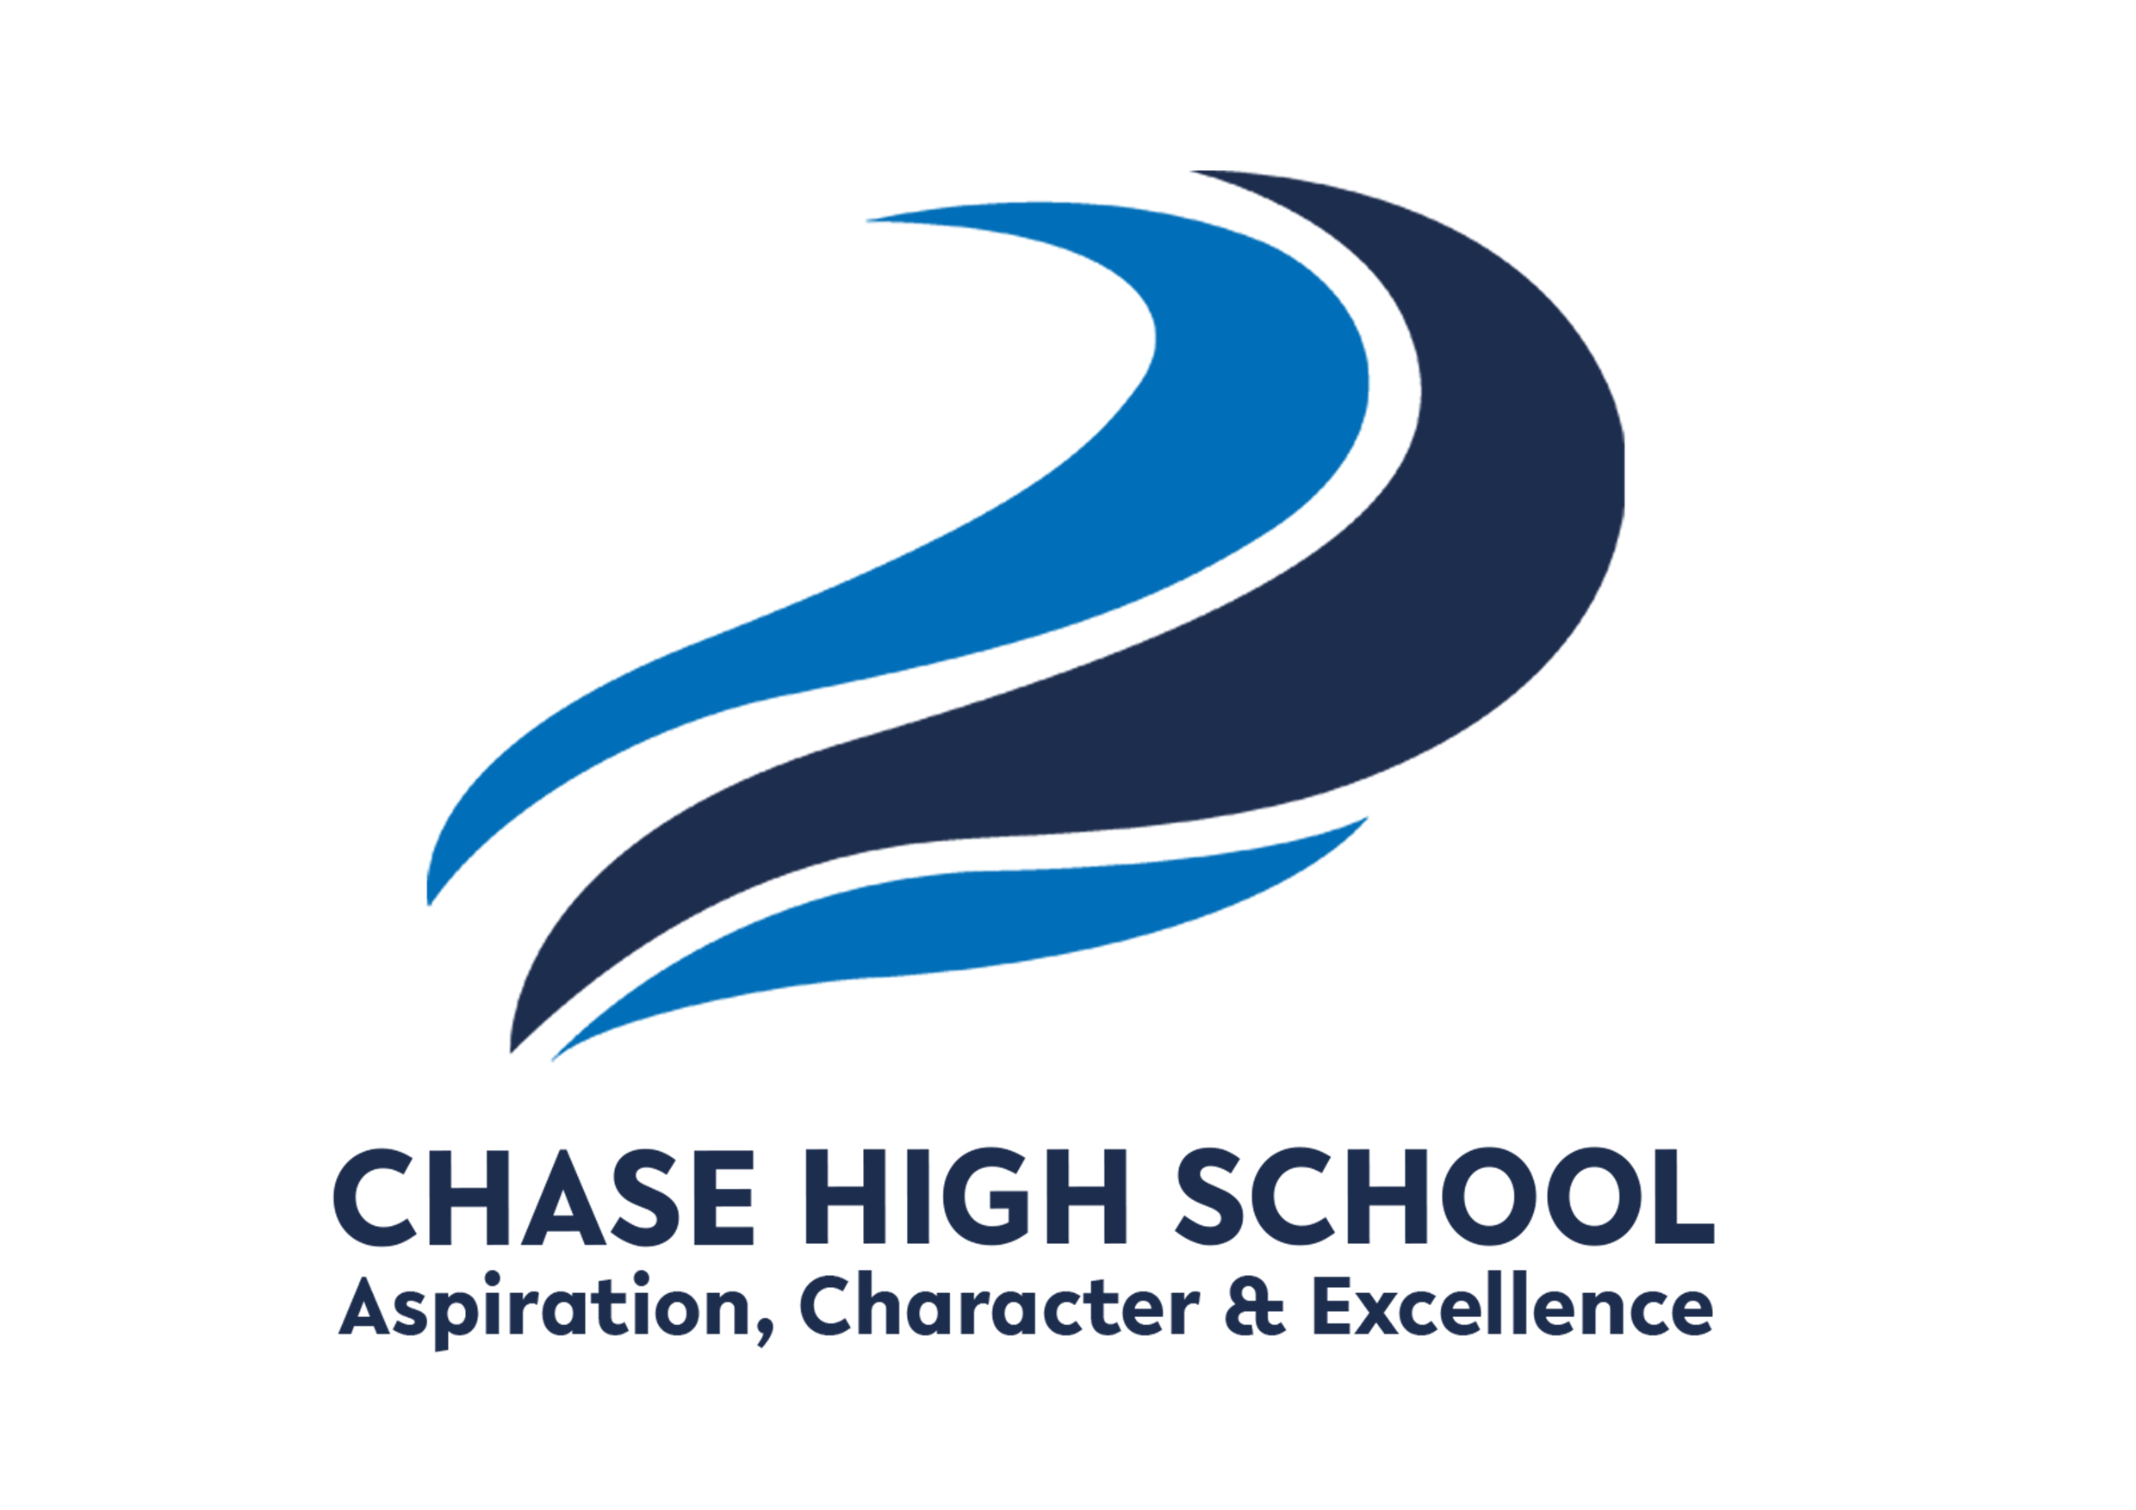
Curriculum Intent: The Media Studies department at Chase High School aims to develop student’s ability to engage with a variety of different media texts. Students will understand the importance of the media industry, the impact it has on the world and how the target audience carefully constructs media text for consumption. They will creatively design, edit and produce their own media products for their coursework, gaining knowledge in different software programmes to produce creative new media products. This course prepares them for creative subject at University or for the world of work in the media industry.
Subject: Media Studies
Year Group: 12 DIPLOMA

TERM 1 | TERM 2 | TERM 3
KNOWLEDGE/SKILLS  Skills Introduction for Media – using Photoshop / camera shots / storyboarding.  Unit 20 Single Camera Techniques  Learning Aim A  A: Understand single camera productions  Camera shots / movement / camera angles – learning to apply these to a variety of different media.  Unit 23 Stop Motion Animation  Learning Aim A  A: Understand the characteristics and processes of stop motion animation  History of Stop Motion – Early techniques / how are they created and an analysis of Stop Motion  Unit 19 Scriptwriting  Learning Aim A  A. The role of a scriptwriter  B: Explore scriptwriting formats and conventions for media products  What do script writers do in each film industry – How to get a commission / how to write a script / who they work with / case studies /pitches / plot and story arcs.  What is the layout of scripts? How are scripts different in the industries? Students learn how to use script writing software – Trelby.  December – Unit 8 Responding to a Commission (Exam Prep) | KNOWLEDGE/SKILLS  January – Unit 8 Responding to a Commission (Exam)  Submitted and marked by Pearsons  Unit 20 Single Camera Techniques  Learning Aim B  B: Explore single camera techniques  Students plan a single camera production of their own. Advert - storyboard / risk assessment / treatment / proposal / production log / shot list / shot log. A day shoot using cameras.  Unit 23 Stop Motion Animation  Learning Aim B  B: Generate materials for a stop motion animation  Students create their own Stop Motion animation – practice Claymation / storyboard / reflect and refine. Premiere Pro skills – how to edit a stop motion.  Unit 19 Scriptwriting  Learning Aim A  A. The role of a scriptwriter  B: Explore scriptwriting formats and conventions for media products  April - Unit 3 Digital Media Skills (Exam)  Skills based scenario - changes each year  Photoshop skills – text / cropping / layout of magazine / wrapping text / adding effects / photoshoot | KNOWLEDGE/SKILLS  May - Unit 3 Digital Media Skills (Exam)  Skills based scenario - changes each year  Submitted and marked by Pearsons  Unit 20 Single Camera Techniques  Learning Aim C  C: Produce a single camera production.  Film and edit a single camera production using Premiere Pro  Unit 23 Stop Motion Animation  Learning Aim C  C: Produce a stop motion animation  Students create their own Stop Motion animation – film and edit.  Unit 19 Scriptwriting  Learning Aim C  C: Produce scripts for media products  Produce a research portfolio / proposal and write a script that is at least 600 words.
KEY ASSESSMENTS  December – Unit 8 Responding to a Commission preparation | KEY ASSESSMENTS  January– Unit 8 Responding to a Commission preparation  March / April – Unit 3 Digital Media Skills | KEY ASSESSMENTS  April / May – Unit 3 Digital Media Skills
Extended reading suggestions and external resources:

https://qualifications.pearson.com/en/qualifications/btec-nationals/creative-digital-media-production-2016.html
Adobe Premiere Pro Classroom in a Book (2024)
Scriptwriting for Film, Television and New Media (2019)

