
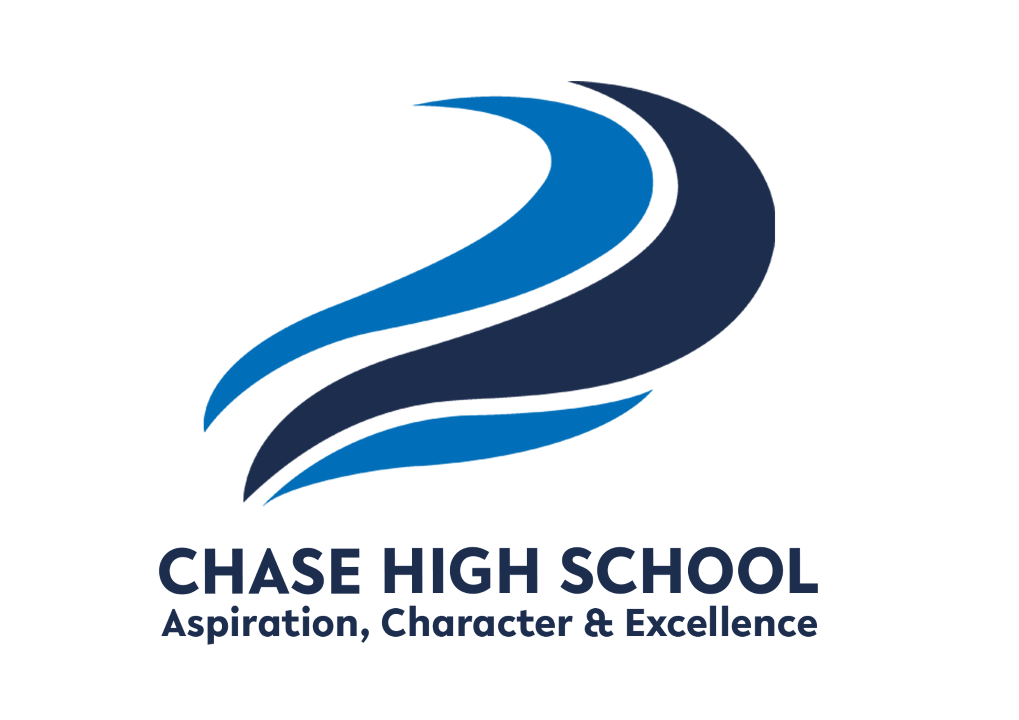
Curriculum Intent: The Media Studies department at Chase High School aims to develop student’s ability to engage with a variety of different media texts. Students will understand the importance of the media industry, the impact it has on the world and how the target audience carefully constructs media text for consumption. They will creatively design, edit and produce their own media products for their coursework, gaining knowledge in different software programmes to produce creative new media products. This course prepares them for creative subject at University or for the world of work in the media industry.
Subject: Media Studies
Year Group: 13 DIPLOMA

TERM 1 | TERM 2 | TERM 3
KNOWLEDGE/SKILLS  Skills Introduction for Media – using Photoshop / camera shots / storyboarding.  Unit 10 Film Production (Fiction)  Learning Aim A  A: Understand codes and conventions of fictional film production  Analyse The Shape of Water / Matrix films / (third film for Distinction) Conventions / genre / mise en scene / editing / sound / similarities and differences.  Unit 21 Film editing Learning Aim A - also covered within this assessment.  A: Understand the techniques and applications of editing for film and television  Unit 10 Film Production (Fiction)  Learning Aim B & C  B: Produce material for a fictional film of a specified genre  C: Apply post-production techniques to a fictional film  Pre- Production – Mind map / research / storyboard / script / risk assessment / contingency plan / shot list.  Production / Post Production - edit / review edit  Unit 21 Film Editing – also covered within assessment  Learning Aim B & C  B: Explore the use of editing tools, techniques and conventions for a specific purpose  C: Create a digitally edited sequence for a specific purpose.  December – Unit 8 Responding to a Commission (RESIT Exam Prep) | KNOWLEDGE/SKILLS  January – Unit 8 Responding to a Commission (RESIT Exam) Submitted and marked by Pearsons  April - Unit 3 Digital Media Skills (RESIT Exam)  Skills based scenario - changes each year  Unit 18 Storyboarding  Learning Aim A & B  A: Understand the use of storyboards in a range of digital media sectors  B: Explore storyboard skills for production purposes  Explore storyboards for different industries - Tv / Film / Games / Animation – layout / designs / transitions camera shots / angles / movements / illustration / annotations.  Learning Aim C  C: Create and review storyboards for digital creative media production.  Draw storyboards for different media sectors.  Unit 7 Media Enterprise  Learning Aim A  A: Develop a brief for the production of a new media product or service  B: Apply enterprise skills to plan the production of a new media product  Planning / research / designing / Photoshop / refining ideas. Mock ups – drawn / digital / write a brief | KNOWLEDGE/SKILLS  May - Unit 3 Digital Media Skills (RESIT Exam)  Skills based scenario - changes each year  Unit 7 Media Enterprise  Learning Aim C & D  C: Produce a new digital media product or service through application of media enterprise skills D: Review media enterprise skills  Create digital designs of a new media product and review of technical and organisation skills.  Unit 24 Sound Editing  Learning Aim A & B  A: Understand the reasons for factual and fictional recorded digital sound  B: Investigate the equipment, techniques and procedures for editing recorded digital sound  Look at different media productions and how sound is used to enhance production. Look at the equipment and editing techniques for sound.  Learning Aim C  C: Edit recorded digital sound for media artefacts  Record own sound and edit using Premiere Pro / Auditions
KEY ASSESSMENTS  December – Unit 8 Responding to a Commission preparation - RESIT | KEY ASSESSMENTS  January– Unit 8 Responding to a Commission preparation  March / April – Unit 3 Digital Media Skills - RESIT | KEY ASSESSMENTS  April / May – Unit 3 Digital Media Skills - RESIT
Extended reading suggestions and external resources:
https://qualifications.pearson.com/en/qualifications/btec-nationals/creative-digital-media-production-2016.html
Adobe Premiere Pro Classroom in a Book (2024)
The SnapRevise Analysis Guides: How To Analyse Films

